# Bangladesh Army University of Engineering & Technology (BAUET)

### Department of Computer Science and Engineering (CSE)

#### Student Personal Information

Photo

|  |  |
| --- | --- |
| 1. Name of the Student | : Md. Arik Rayhan |
| 1. Student ID | : 20104033 |
| 1. Father’s Name | : Md. Ashabul Alam |
| 1. Mother’s Name | : Rehana Parvin |
| 1. Present Address | : Nurmoholla, Ishwardi, Pabna. |
| 1. Permanent Address | : Nurmoholla, Ishwardi, Pabna. |
| 1. Contact Details of Student |  |
| 1. Mobile No | : 01780873393 |
| 1. Email address | : mdarikrayhan@gmail.com |
| 1. Education Status | : Enrolled in a Bachelor of Science (B.Sc.) program  Computer Science and Engineering (CSE). |
| 1. Nationality | : Bangladeshi |

|  |  |  |
| --- | --- | --- |
| **Examination** | **Institution** | **Marks/GPA/CGPA** |
| SSC | Sara Marwari Model School and College | GPA 5.00 |
| HSC | Ishwardi Government College | GPA 4.25 |
| B.Sc. in CSE | Bangladesh Army University of Engineering & Technology | CGPA 3.68  (Till 5th Semester) |

Signature of the student

Official (Institution)

Signature and Seal of the concerned Teacher

## Bangladesh Army University of Engineering & Technology (BAUET)

### Department of Computer Science and Engineering

**Evaluation on Industrial Training**

**BAUET (Students (CSE-11th Batch, Years-3, Semester-2)**

Name of the Student : Nadira Anjum Biva

Student ID : 20104032

Department : CSE

Session : 2020-2021

Name of the Industry with Details Address : BRACNet (16 Mohakhali C/A, Dhaka-1212)

**Trainer’s Assessment of the Trainee**

|  |  |  |  |  |
| --- | --- | --- | --- | --- |
| SL.NO | Description | Full Marks | Marks Obtained | Remarks |
| 1. | Attendance | 10 |  |  |
| 2. | Conduct | 10 |  |  |
| 3. | Initiative | 10 |  |  |
| 4. | Punctuality | 10 |  |  |
| 5. | Participation in the actual work | 10 |  |  |
| 6. | Ability of understanding | 10 |  |  |
|  | Total Marks | 60 |  |  |

**Date: 07-06-2023** Signature

(Officer-in- Charge, Training)

**WEEKLY ACTIVITIES REPORT (WEEK-1, 2, 3 & 4)**



# Bangladesh Army University of Engineering & Technology (BAUET)

**Department of Computer Science & Engineering (CSE)**

# Bangladesh Army University of Engineering & Technology (BAUET)

## Department of Computer Science & Engineering (CSE)

**The above statement is to be attested by the training-in charge**

Name of the Training In–Charge (With Position):

Afrin Kawsar, Assistant Manager, Human Resources, BRACNet.

Signature (office seal)

Date: 07-06-2023

|  |  |
| --- | --- |
| **Index** | |
| Date | Activity |
| 15-05-2023 | BRACNet |
| 16-05-2023 | Network instruction |
| 17-05-2023 | System and Cloud solution |
| 18-05-2023 | Cyber security |
| 21-05-2023 | Web technology |
| 22-05-2023 | IPTS:(IP Telephone Service) |
| 23-05-2023 | Internet Service Provider |
| 24-05-2023 | Network Technologies Fundamentals |
| 25-05-2023 | Network Security |
| 28-05-2023 | UI /UX |
| 29-05-2023 | Bandwidth |
| 30-05-2023 | Fiber Connectivity |
| 31-05-2023 | Radio Technology |
| 01-06-2023 | Data Center Visit |
| 04-06-2023 | Call Center |
| 05-06-2023 | Supply Chain |
| 06-06-2023 | Sales & Customer Handle |
| 07-06-2023 | Accounting |

#### WEEKLY REPORT (WEEK-1st)

|  |  |  |  |
| --- | --- | --- | --- |
| **Date** | **Time of Arrival** | **Time of Depart** | **Today’s Assignment/Section** |
| 15-05-2023 | 9:00 AM | 3:00 PM | BRACNet |

BracNet Limited is a leading internet service provider (ISP) and IT solutions company based in Bangladesh. Here is some information about BracNet Limited:

**Background:**

BracNet Limited was established in 1996 as a subsidiary of BRAC, one of the largest non-governmental organizations in the world.

The company was founded with the mission to provide reliable and affordable internet connectivity and IT solutions to businesses and individuals in Bangladesh.

**Services:**

Internet Connectivity: BracNet offers high-speed broadband internet services to residential, commercial, and corporate customers. They provide various connection options, including fiber-optic, wireless, and satellite connections.

Data Center Services: BracNet operates state-of-the-art data centers that offer secure and reliable hosting, colocation, and cloud services to businesses.

IT Solutions: The company provides a range of IT solutions, including network design and implementation, system integration, IT infrastructure management, and software development.

Managed Services: BracNet offers managed services to assist businesses in effectively managing their IT infrastructure, including network monitoring, security services, and helpdesk support.

Value-Added Services: BracNet provides value-added services such as domain registration, web hosting, email services, and online backup solutions.

**Infrastructure and network:**

BracNet has built a robust and extensive network infrastructure to ensure reliable and high-speed internet connectivity.

The company has a network of fiber optic cables, wireless towers, and satellite connectivity to reach both urban and rural areas of Bangladesh.

They have partnered with international submarine cable operators to ensure seamless connectivity with the global internet backbone.

**Clientele:**

BracNet serves a diverse range of clients, including small and medium-sized enterprises (SMEs), large corporations, educational institutions, government organizations, and individual customers.

Their clients span various industries, including banking and finance, healthcare, education, manufacturing, and telecommunications.

**Commitment to quality and customer service:**

BracNet places a strong emphasis on delivering quality services and maintaining high customer satisfaction.

They have a dedicated customer support team available 24/7 to address customer queries and technical issues promptly.

The company continuously invests in upgrading its network infrastructure and technology to ensure the best possible service for its customers.

**Social Initiatives:**

As a subsidiary of BRAC, BracNet is aligned with the organization's social mission of poverty alleviation and sustainable development.

The company actively supports various social initiatives and community development programs in Bangladesh.

BracNet Limited has established itself as a trusted and reliable internet service provider and IT solutions company in Bangladesh. With its commitment to quality, extensive network infrastructure, and wide range of services, BracNet continues to play a significant role in bridging the digital divide and driving digital transformation in the country

|  |  |  |  |
| --- | --- | --- | --- |
| **Date** | **Time of Arrival** | **Time of Depart** | **Today’s Assignment/Section** |
| 16-05-2023 | 9:30 AM | 3:30 PM | Network instruction |

A computer network's rules and orders for data transmission, reception, and processing are known as network instructions. Network protocols provide these instructions, which are used to format, address, route, order, and identify errors in data packets or frames. They guarantee uniform communication and compatibility between hardware and software parts of networks. The implementation of network instructions into network hardware and software enables effective and dependable data transfer throughout the network.

1. Network solution design

2. Data-center solution

3. System Integration

4. SD wan

5. Network service migration

6. Service license

7. Lan infostructure design

8. Wi-Fi 68

|  |  |  |  |
| --- | --- | --- | --- |
| **Date** | **Time of Arrival** | **Time of Depart** | **Today’s Assignment/Section** |
| 17-05-2023 | 9:45 AM | 3:45 PM | System and Cloud solution |

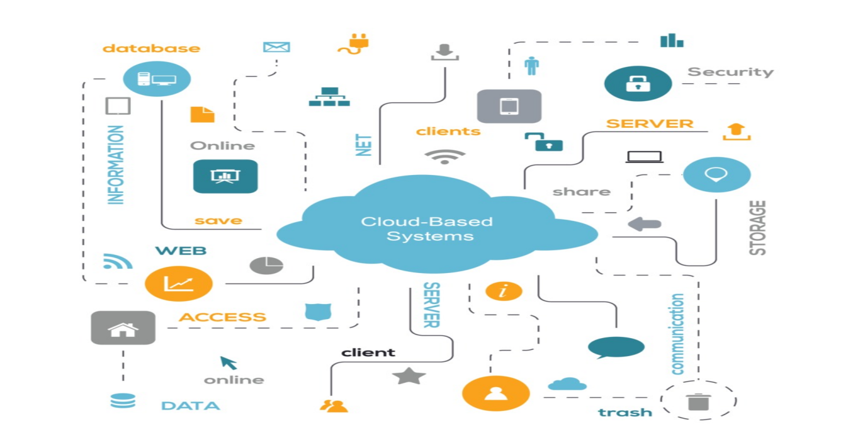

A cloud-based system, sometimes referred to as cloud computing, is a general term for anything that incorporates the internet-based delivery of hosted services.

A cloud can be either public or private. Anyone with an internet connection may buy services from a public cloud.

A private cloud is a proprietary network or data center that offers services to a restricted group of people with constrained access and privileges. Whether private or public, cloud computing strives to provide simple access to computer resources and information technology services.

In order to hasten agency adoption of cloud-based solutions and improve the rate at which their agencies embrace new technology, the federal government switched from a "cloud first" strategy to a "cloud smart" plan in 2017.  In this in-depth guide about cloud-based systems, we will cover what these systems are, provide some examples, explain what they are used for, and their benefits

**Server and storage solutions:**

1. Active directory

2. Azabon active directory

3. Print server solution

4. Window title system solution

5. Domain naming system

6. Storage &backup solution

7. Cloud instances solution

|  |  |  |  |
| --- | --- | --- | --- |
| **Date** | **Time of Arrival** | **Time of Depart** | **Today’s Assignment/Section** |
| 18-05-2023 | 9:00 AM | 3:00PM | Cyber security |

Cybersecurity is the protection of internet-connected systems such as hardware, software and data from cyber threats. The practice is used by individuals and enterprises to protect against unauthorized access to data centers and other computerized systems.

Cybersecurity plays a crucial role in protecting various real-life applications and sectors from cyber threats. Here are some examples of real-life applications where cybersecurity is essential:

1. Defense and Military Systems
2. Education Institutions
3. Transportation and Logistics
4. Government Services and Elections
5. Energy and Utilities
6. Cloud Computing and Data Centers
7. Social Media and Online Platforms
8. Law Enforcement and Public Safety
9. Research and Development

|  |  |  |  |  |  |
| --- | --- | --- | --- | --- | --- |
| **Punctuality** | **Initiatives** | **Innovativeness** | **Sense of responsibility** | **Sense of discipline** | **Drive for completion of task** |
|  |  |  |  |  |  |
|  |  |  |  |  |  |

(The boxes are to be filled in by any suitable term from ‘very good’, ‘good’, and ‘average’, ‘poor’.)

Supervisor’s signature Designation: Assistant Manager

Date: 07-06-2023

#### WEEKLY REPORT (WEEK-2nd)

|  |  |  |  |
| --- | --- | --- | --- |
| **Date** | **Time of Arrival** | **Time of Depart** | **Today’s Assignment/Section** |
| 21-05-2023 | 9:00 AM | 3:00 PM | Web technology |

Web technology refers to the collection of tools, languages, and frameworks used to build and operate websites and web applications. It involves two main aspects: front-end development and back-end development.

Front-end development focuses on the user-facing part of a website or web application. Front-end developers use languages such as HTML, CSS, and JavaScript to create the visual and interactive elements that users see and interact with. HTML is used to structure the content, CSS is used to style the presentation and layout, and JavaScript adds interactivity and functionality to the front end. Front-end development also involves working with frameworks like React, Angular, or Vue.js, which provide pre-built components and libraries to speed up development.

Back-end development, on the other hand, deals with the server side of a website or web application. Back-end developers handle tasks such as server management, database integration, and application logic. They use programming languages like PHP, Python, Ruby, Java, or Node.js to build the server-side components. Back-end development also involves working with frameworks like Django, Laravel, Ruby on Rails, or Express, which provide tools and libraries to simplify server-side development tasks. Back-end developers focus on ensuring the security, efficiency, and performance of the web application.

Front-end and back-end development are interconnected and work together to create a functional and seamless web experience. Front-end developers focus on the user interface, design, and interactivity, making sure the website or application is visually appealing and easy to use. Back-end developers handle behind-the-scenes tasks, such as handling data storage, processing user inputs, and managing server-side operations. Both front-end and back-end developers need to collaborate effectively to ensure a cohesive and well-functioning web application.

|  |  |  |  |
| --- | --- | --- | --- |
| **Date** | **Time of Arrival** | **Time of Depart** | **Today’s Assignment/Section** |
| 22-05-2023 | 9:30 AM | 3:30 PM | IPTS:(IP Telephone Service) |

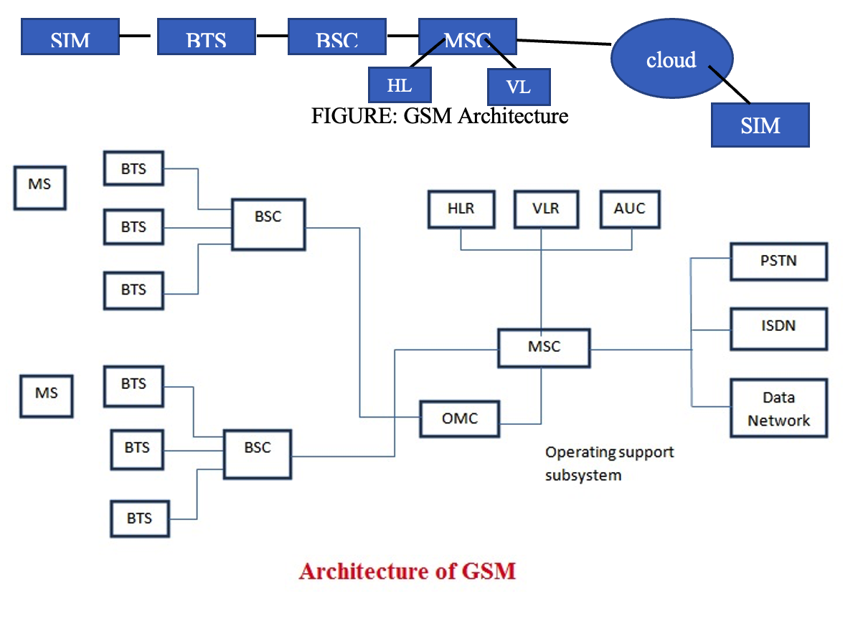

|  |  |  |  |
| --- | --- | --- | --- |
| **Date** | **Time of Arrival** | **Time of Depart** | **Today’s Assignment/Section** |
| 23-05-2023 | 9:00 AM | 3:00 PM | Internet Service Provider |

An ISP (Internet Service Provider) is a company that provides individuals and organizations access to the internet and other related services. An ISP has the equipment and the telecommunication line access required to have a point of presence on the internet for the geographic area served.

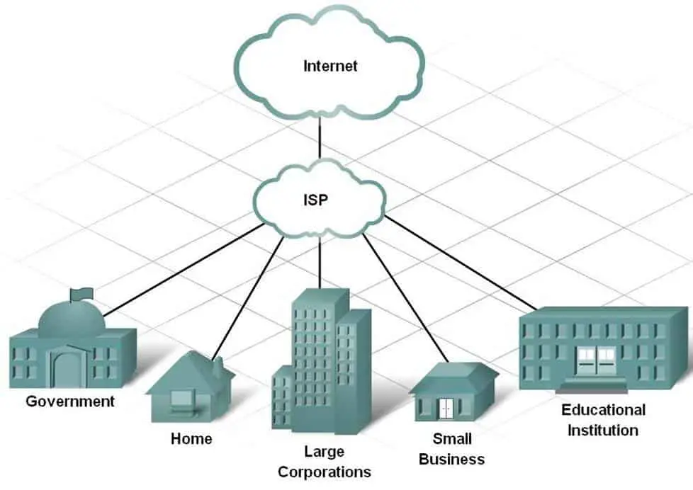

ISPs are connected to one or more high-speed internet lines. Larger ISPs have their own high-speed leased lines, so they are less dependent on telecommunications services and can provide better service to their customers.

ISPs also keep thousands of servers in data centers -- the number of servers depends on their internet service area. These large data centers manage all customer traffic. Multiple ISPs are also connected to large [backbone](https://www.techtarget.com/searchnetworking/definition/backbone) routing centers.

ISPs are grouped into the following three tiers:

* **Tier 1 ISPs.** These ISPs have the most global reach and own enough physical network lines to carry most traffic on their own. They also negotiate with other tier 1 networks to allow free traffic to pass through to other tier 1 providers. Tier 1 ISPs typically sell network access to tier 2 ISPs.
* **Tier 2 ISPs.** These ISPs have regional or national reach and are service providers that connect tier 1 and tier 3 ISPs. They have to purchase access to larger tier 1 networks, but are peers with other tier 2 ISPs. Tier 2 networks focus on consumer and commercial customers.
* **Tier 3 ISPs.** These ISPs connect customers to the internet using another ISP's network. Tier 3 ISPs use and pay higher-tier ISPs for access to internet services. They focus on providing internet access to local businesses and consumer markets.

|  |  |  |  |
| --- | --- | --- | --- |
| **Date** | **Time of Arrival** | **Time of Depart** | **Today’s Assignment/Section** |
| 24-05-2023 | 9:35 AM | 3:00 PM | Network Technologies Fundamentals |

**Network:**

Group of components or devices connected together to give the user a certain service (application).

• Importance of Networks:

✓Easy access and sharing of information

✓Sharing of expensive devices and network resources

✓Modern Technologies (IP telephony, Video Conferencing)

• Network has three main components

✓ Computers (servers and hosts) - Source of applications (network-aware applications) –

ex: HTTP (Hyper Text Transmission Protocol), FTP (File Transfer Protocol), SMTP (Simple Mail Transfer Protocol) POP3 (Post Office Protocol 3) Telnet

✓ Network Devices - Devices that interconnect different computers together - ex: Repeaters, hubs, bridges, switches, router, NICs and modems

✓ Connectivity - Media that physically connects the computers and network devices - ex: Wireless and cables

Network Types

LAN (Local Area Network):

• It is a group of network components that work within a small area

• Ex.: Token Ring, FDDI, Ethernet, Fast Ethernet

MAN (Metropolitan Area Network):

• It is a group of LANs that are interconnected over a small area within a city like Cairo.

• Ex.: Metro Ethernet.

WAN (Wide Area Network):

• It is a group of LANs that are interconnected within a large area.

•Ex.: FR, ISDN, X.25, Analog dialup, ATM.

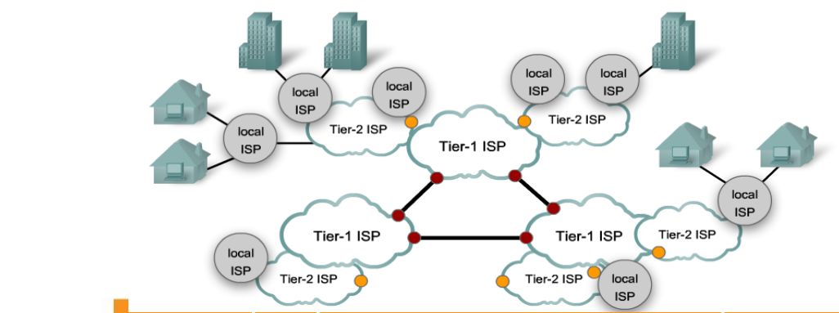

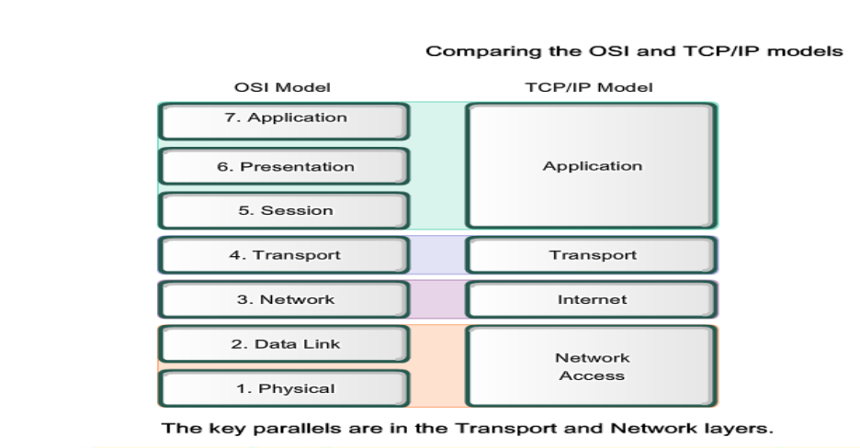

|  |  |  |  |
| --- | --- | --- | --- |
| **Date** | **Time of Arrival** | **Time of Depart** | **Today’s Assignment/Section** |
| 25-05-2023 | 9:00 AM | 4:00 PM | Network Security |

Network security is a broad term that covers a multitude of technologies, devices and processes. In its simplest term, it is a set of rules and configurations designed to protect the integrity, confidentiality and accessibility of computer networks and data using both software and hardware technologies. Product’s Introduction

• VPN as a service

• Customized Firewall solution

• Hardware-based Anti-DDoS appliance

**Enterprise LAN/WLAN Solution**

Enterprise LAN & Wi-Fi means structural local area network via Ethernet Cable or Wireless AP. Enterprise LAN and Wi-Fi are very much needed for smooth communication. A haphazard local area network causes more trouble and takes time to troubleshoot. The demand for Wi-Fi internet has ascended due to the stretch of portable gadgets like Mobile, Tablet and Laptop. Moreover, Wi-Fi Internet has been increasingly popular among dwellers due to its cost-effective solution. BracNet provides enterprise network solution as per client requirement which is not limited to LAN-WAN but also controller-based Wi-Fi solution.

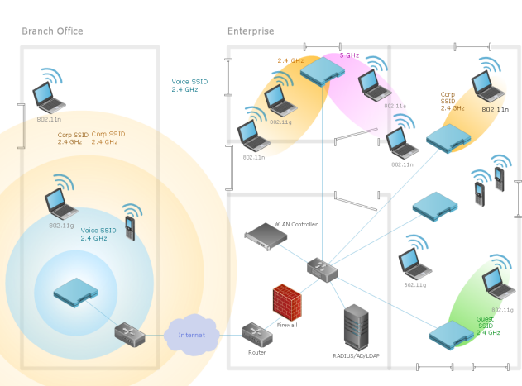

**Surveillance System**

The word ‘surveillance’ means to observe a specific area or to monitor the activities of an individual or a group. It is very useful to the government to maintain social control, monitor and recognize threats, and investigate criminal activity. BracNet aim to provide world-class surveillance solutions that can address the security concerns of small, medium and large enterprises. Being an established solution provider catering to a wide range of customers, we understand the unique needs of different industries.

**Product Specification**

* Network Cameras
* PTZ Cameras
* HDCVI Cameras
* Thermal Cameras
* Explosion Proof Cameras
* Anti-corrosion Cameras
* Network Video Recorders
* HDCVI Recorders
* Video Wall
* Managed IT Service

Managed IT services can encompass many responsibilities but typically include: Monitoring and management of hardware and infrastructure. Security services, including monitoring or incident response. Configuration, monitoring, and management of services. Managed IT service can be In-House or Remotely.

|  |  |  |  |  |  |
| --- | --- | --- | --- | --- | --- |
| **Punctuality** | **Initiatives** | **Innovativeness** | **Sense of responsibility** | **Sense of discipline** | **Drive for completion of**  **task** |
|  |  |  |  |  |  |
|  |  |  |  |  |  |

(The boxes are to be filled in by any suitable term from ‘very good’, ‘good’, ‘average’, and ‘poor’.)

Supervisor’s signature Designation: Assistant Manager

Date: 07-06-2023

#### WEEKLY REPORT (WEEK-3rd)

|  |  |  |  |
| --- | --- | --- | --- |
| **Date** | **Time of Arrival** | **Time of Depart** | **Today’s Assignment/Section** |
| 28-05-2023 | 9:00 AM | 3:00 PM | UI /UX |

UI (User interface) refers to the screens, buttons, toggles, icons, and other visual elements that you interact with when using a website, app, or other electronic device. UX (user experience) refers to the entire interaction you have with a product, including how you feel about the interaction. A user can engage with a product or service by using a user interface (UI), which is essentially a collection of screens, pages, and visual elements (such as buttons and icons). The phrase “User Experience” refers to how a person reacts to each component of a company's goods and services (UX).



**Why do we use UI UX design?**

User experience (UX) design is the process design teams use to create products that provide meaningful and relevant experiences to users. UX design involves the design of the entire process of acquiring and integrating the product, including aspects of branding, design, usability and function.

**Application:**

UI focuses on the user interface design, UX covers the overall user experience as they interact with your product or service. UI design tools give designers what they need to design accurate hi-fi wireframes, mockups, and prototypes and render minimally viable products. **Adobe XD** is Adobe's offering for UI/UX designers. Adobe XD offers vector-based UI tools that can be used to create prototypes and mockups. The interface is similar to all other Adobe interfaces, so the sense of familiarity kicks in when working on the software. mockups, and prototypes and render minimally viable products.

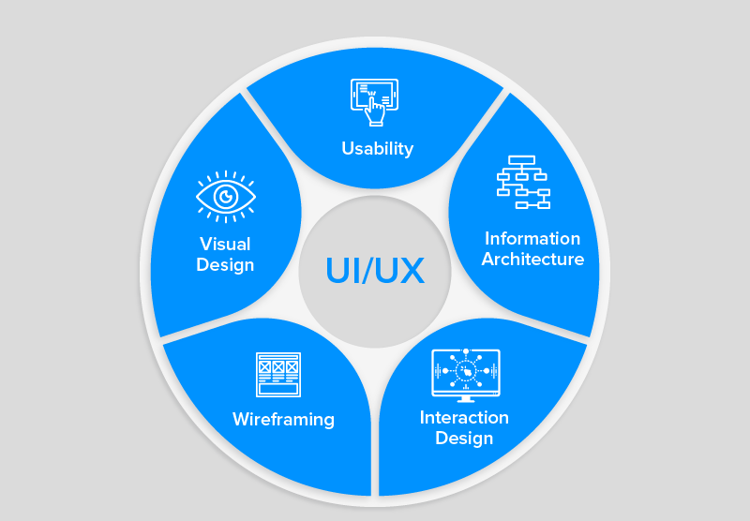

|  |  |  |  |
| --- | --- | --- | --- |
| **Date** | **Time of Arrival** | **Time of Depart** | **Today’s Assignment/Section** |
| 29-05-2023 | 9:00 AM | 3:00 PM | Bandwidth |

What is bandwidth?

Bandwidth specifically refers to the capacity at which a network can transmit data. For example, if the bandwidth of a network is 40 Mbps, it implies that the network cannot transmit data faster than 40 Mbps in any given case. The maximum amount of data transmitted over an internet connection in a given amount of time. Bandwidth is often mistaken for internet speed when it's actually the volume of information that can be sent over a connection in a measured amount of time – calculated in megabits per second (Mbps)

Why is bandwidth important?

Bandwidth is important for determining how fast a web page loads on your browser. For that reason, it's one of the most important things to consider when choosing a platform for your website. Typically, a website that's loaded with heavy images and long videos will need a higher bandwidth of 25 Mbps or above.

3 types of bandwidths:

* Public Wireless
* Public Broadband
* Hybrid Software-Defined Wide Area Networks (SD-WAN)

What is the total bandwidth of Bangladesh?

Bangladesh has a total capacity to provide 3,345.65 Gbps bandwidth whereas the domestic demand is 2,496.48 Gbps.

What is Bandwidth Utilization?

Bandwidth utilization refers to the amount of bandwidth consumed on a network or network segment and the breakdown of its composite traffic. Understanding how bandwidth is utilized in a network is of critical importance to a network manager who is chiefly responsible for ensuring peak network performance. By using sophisticated network monitoring software, they can track traffic throughout large and complex networks and determine how bandwidth is being utilized. For instance, software solutions can monitor bandwidth utilization by port, and even by direction, which is extremely useful in pinpointing problems or to justify additional bandwidth. They can then enact policies that prioritize traffic for high-demand applications.

What are the advantages and Disadvantages of bandwidth?

Having a higher bandwidth means you will be able to achieve a higher data transfer rate which in turn leads to shorter download times. This is especially significant when downloading large files.

Similarly, a low bandwidth connection servicing multiple network requests will severely slow speeds. A high bandwidth connection can service many requests and users without sacrificing precious speed. Again, it's important to remember that low bandwidth means slow network performance.

What is bandwidth in a network?

Bandwidth in networking is the maximum possible data transfer rate of a network or internet connection. Throughput is the actual data transferred successfully in a network. Measuring network bandwidth doesn't consider whether a test data transfer results in successful or unsuccessful data transmission

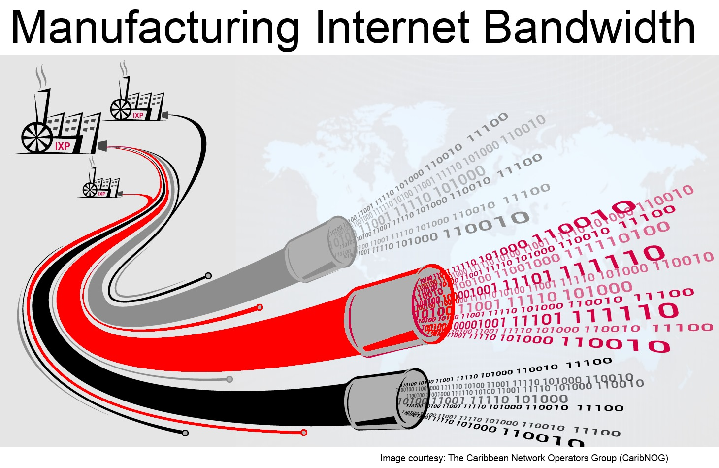

|  |  |  |  |
| --- | --- | --- | --- |
| **Date** | **Time of Arrival** | **Time of Depart** | **Today’s Assignment/Section** |
| 30-05-2023 | 9:00 AM | 3:00 PM | Fiber Connectivity |

**What is Fiber Connectivity?**

Fiber optic internet is a data connection carried by a cable filled with thin glass or plastic fibers. Data travels through them as beams of light pulse in a pattern. Fiber optic internet speeds are about 20 times faster than regular cable at 1 Gbps

**Media Converter Connectivity:**

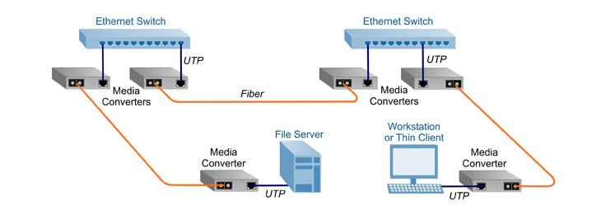

**Solution:**

❑ Restoring the Fiber if Fiber Cut happened or core bend

in TJB

❑ For DB High issue, need to do OTDR, as per OTDR

Result need to check

❑ Need to Check UTP Cable, Connector, and Switch Port

❑ Need to Change Patch Cord if damaged

❑ MC and Adapter need to be changed and need to

check the voltage

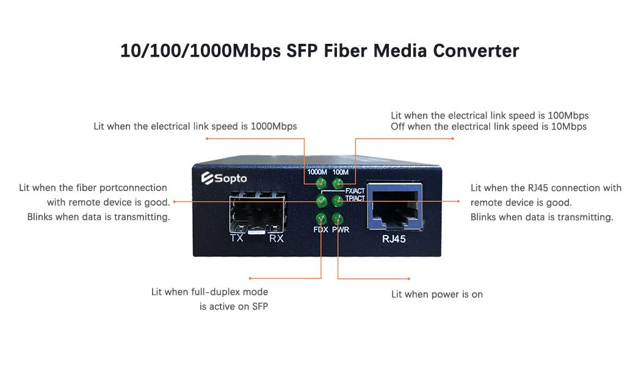

**ONU Connectivity / FTTX Network:**

❑ Restoring the Fiber if a Fiber Cut happened or the core bend or Splitter

got damaged in TJB

❑ For DB High issue, need to do OTDR, as per OTDR Result need to

check

❑ Need to Check UTP Cable, Connector

❑ Need to Change Patch Cord if damaged

❑ ONU and Adapter need to be changed

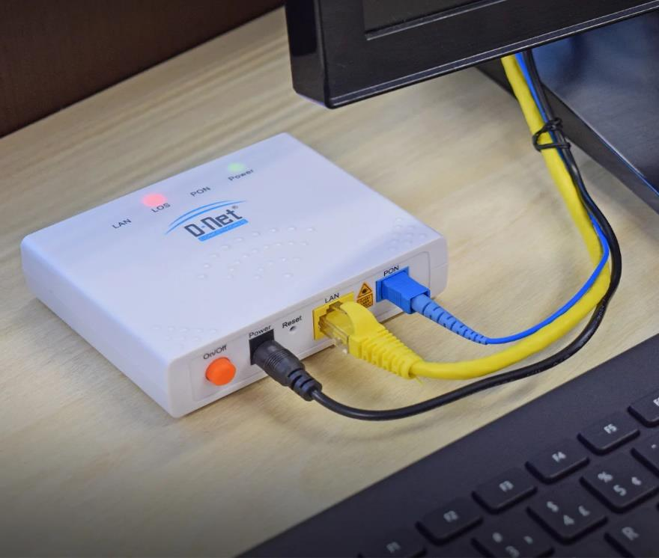

NTTN Connectivity:

❑ Restoring the Fiber if Fiber Cut happened or the Core Bend in TJB

❑ For DB High issue, need to do OTDR, as per OTDR Result need to check

❑ Need to check the modular

❑ Need to check the Port in Switch or Router

❑ Need to Change Patch Cord if damaged

❑ MC and Adapter need to be changed if damaged

❑ Mentioned above also needs to be done by the NTTN on their LDP side

SFP Modular Connectivity:

❑ Restoring the Fiber if Fiber Cut happened or the Core Bend in TJB

❑ For DB High issue, need to do OTDR, as per OTDR Result need to

check

❑ Need to check the modular

❑ Need to check the SFP Port in Switch or Router

❑ Need to Change Patch Cord if damaged

❑ Slotted MC and Adapter need to be changed if damaged

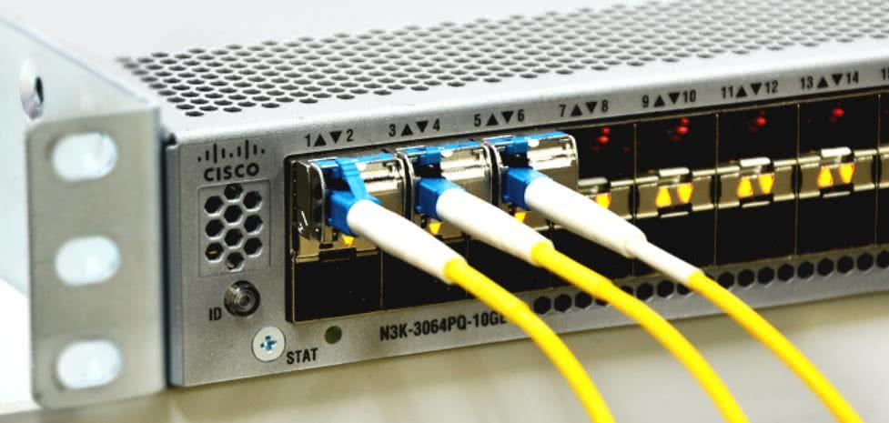

|  |  |  |  |
| --- | --- | --- | --- |
| **Date** | **Time of Arrival** | **Time of Depart** | **Today’s Assignment/Section** |
| 31-05-2023 | 9:00 AM | 3:00 PM | Radio Technology |

Radio is the technology of signaling and communicating using radio waves. Radio waves are electromagnetic waves of frequency. They are generated by an electronic device called a transmitter connected to an antenna which radiates the waves and is received by another antenna connected to a radio receiver.



**Radio Old and Existing Technology of BRACNet:**

SISO refers to a wireless communications system in which one antenna is used at the source (transmitter) and one antenna is used at the destination(receiver).



MIMO is a wireless technology that uses multiple transmitters and receivers to transfer more data at the same time.

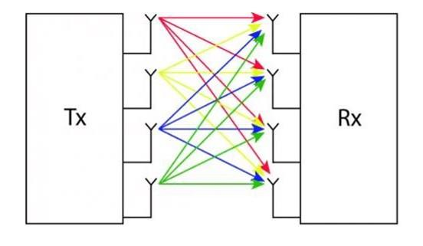

**Existing Radio Brands/Model of BRACNet:** Two radio brands currently BRACNet is using (Ubiquiti & Cambium)

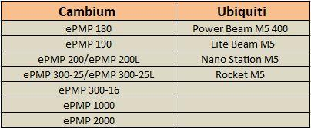

|  |  |  |  |
| --- | --- | --- | --- |
| **Date** | **Time of Arrival** | **Time of Depart** | **Today’s Assignment/Section** |
| 01-06-2023 | 9:00 AM | 3:00 PM | Data Centre Visit |

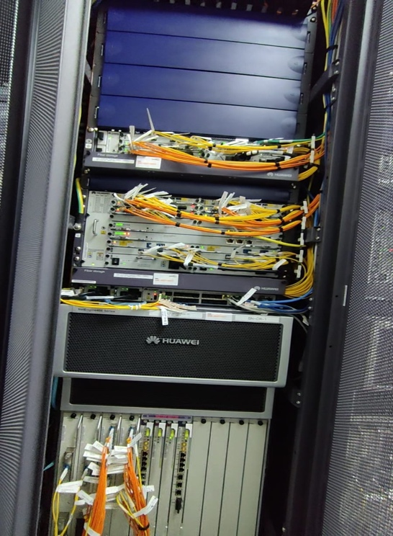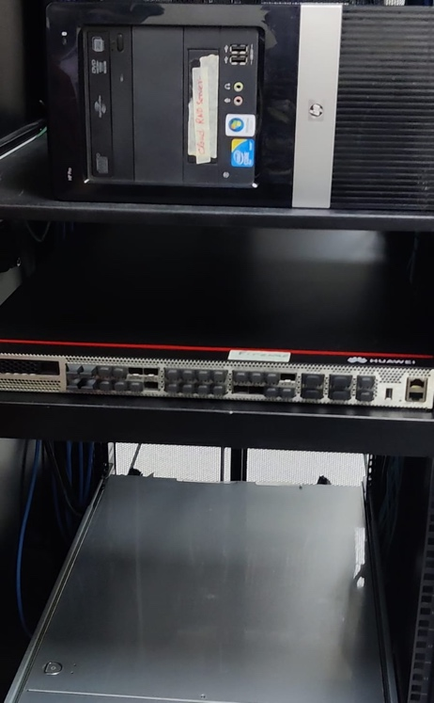

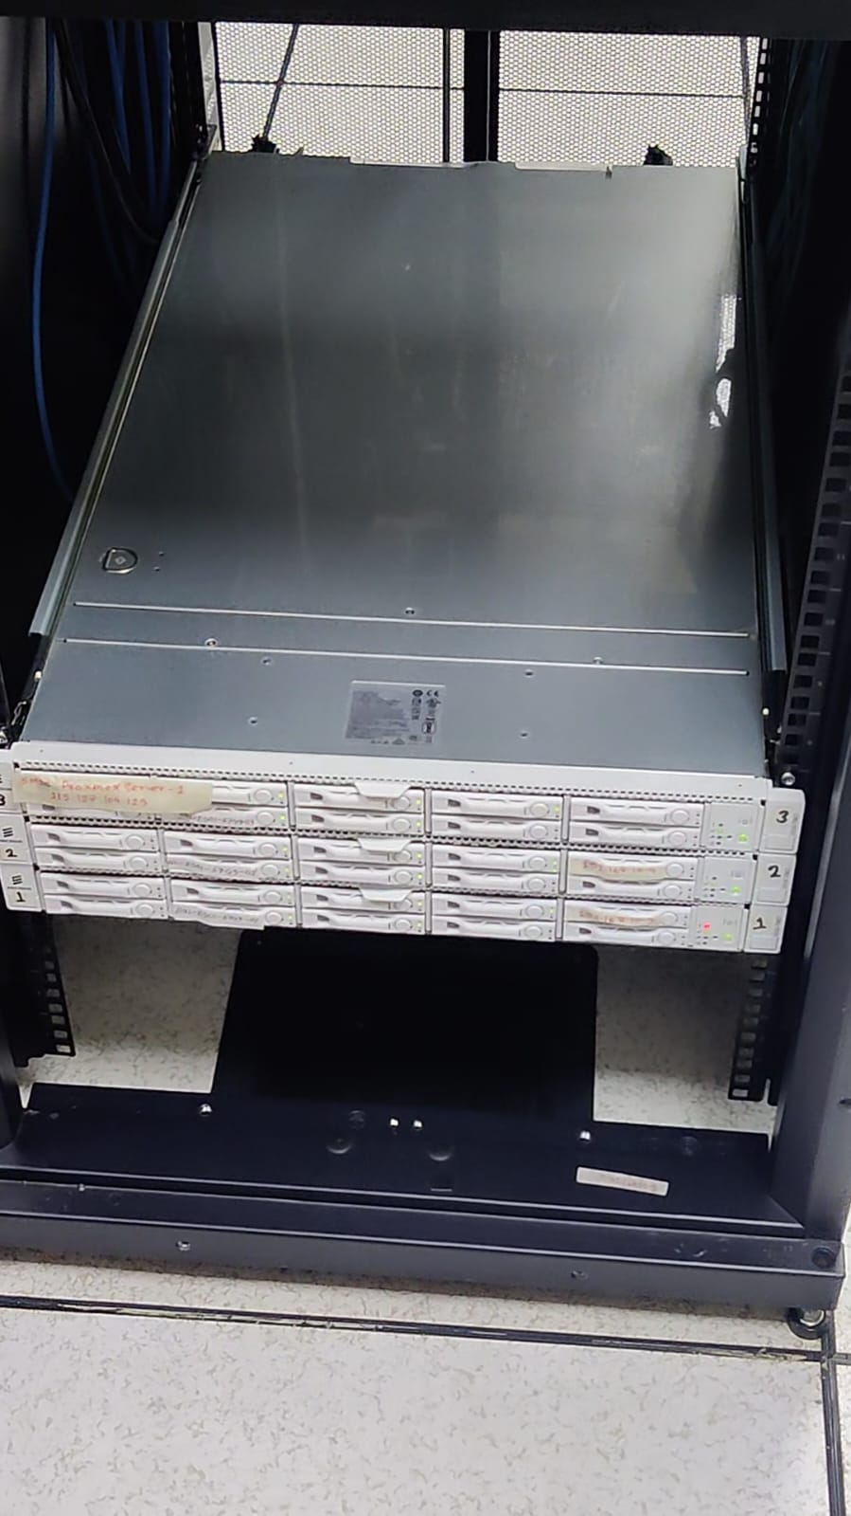

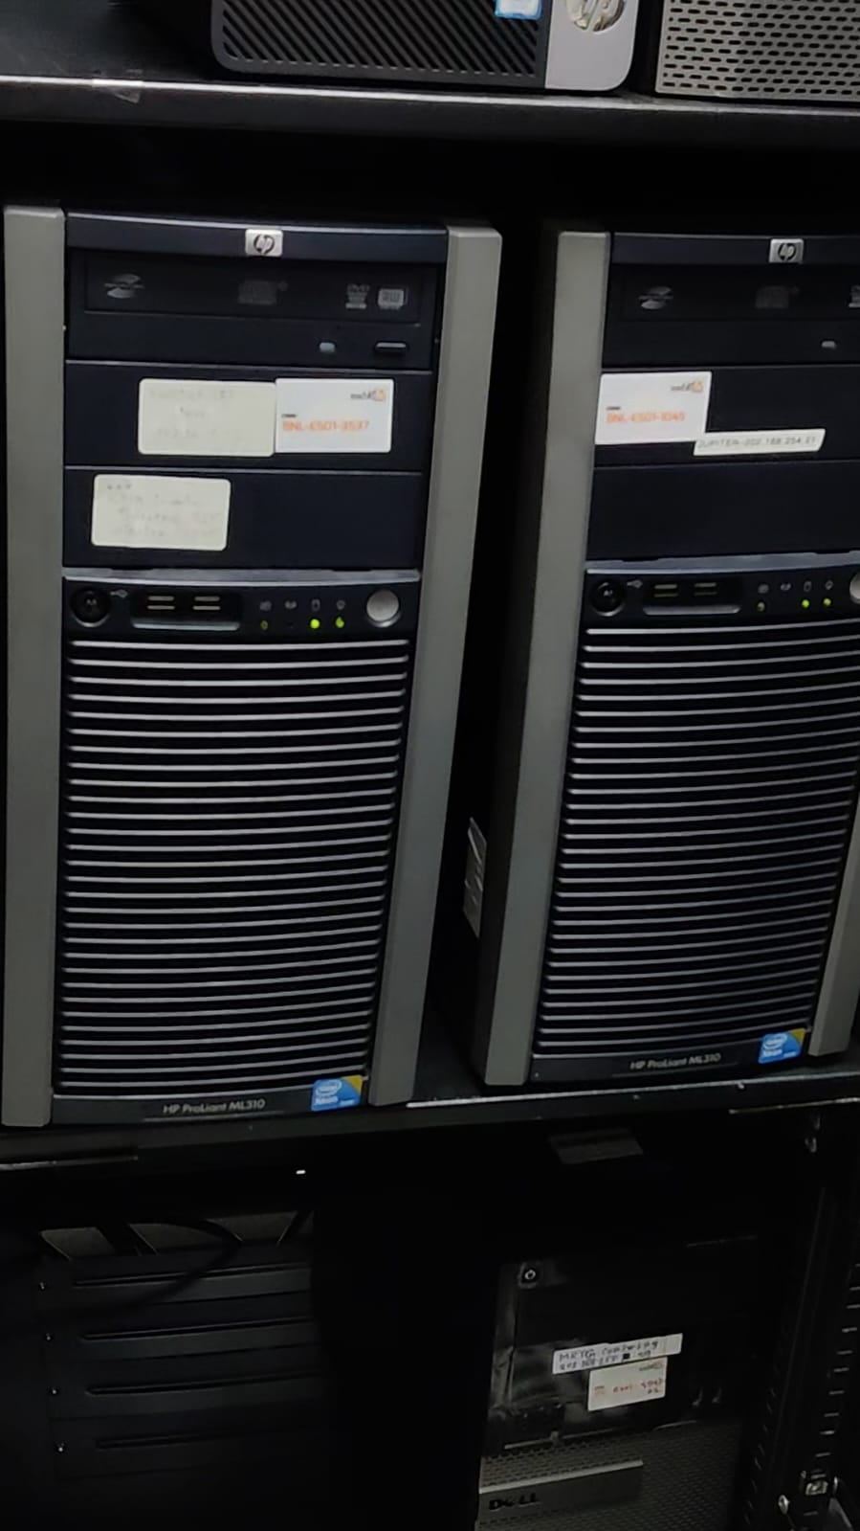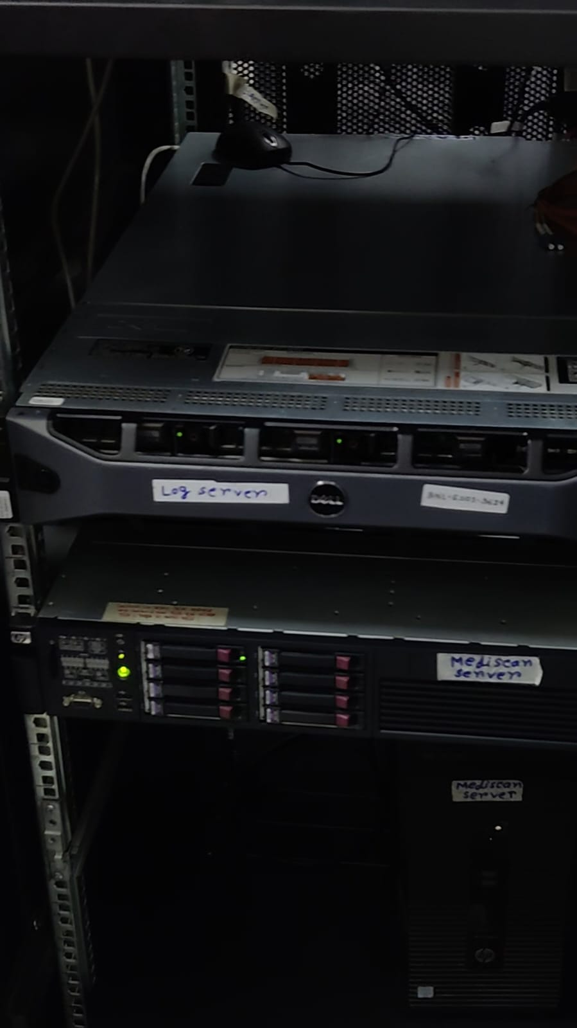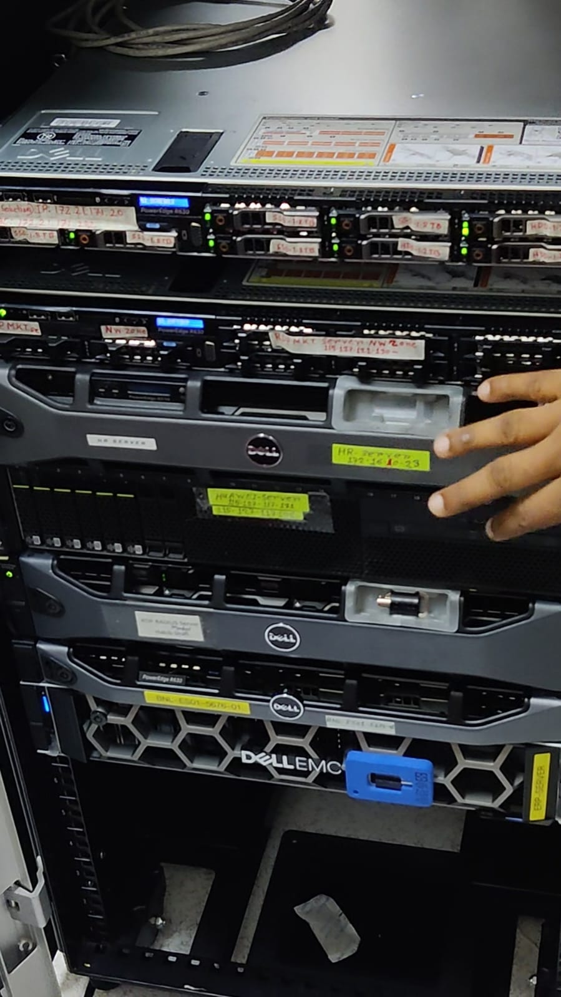

|  |  |  |  |  |  |
| --- | --- | --- | --- | --- | --- |
| **Punctuality** | **Initiatives** | **Innovativeness** | **Sense of responsibility** | **Sense of discipline** | **Drive for completion of task** |
|  |  |  |  |  |  |
|  |  |  |  |  |  |

(The boxes are to be filled in by any suitable term from ‘very good’, ‘good’, and ‘average’, ‘poor’.)

Supervisor’s signature Designation: Assistant Manager

Date: 07-06-2023

#### WEEKLY REPORT (WEEK-4th )

|  |  |  |  |
| --- | --- | --- | --- |
| **Date** | **Time of Arrival** | **Time of Depart** | **Today’s Assignment/Section** |
| 4-06-2023 | 9:00AM | 3:00 PM | Call Center |

A call center is a centralized office or facility where a company handles inbound and outbound telephone calls. It is staffed by agents who handle customer inquiries, provide support, take orders, make sales, and perform other phone-related tasks. Call center are commonly used by businesses in various industries, including customer service, telemarketing, technical support, and sales.



Call centers typically utilize telecommunication technologies, such as telephone systems, computer systems, and customer relationship management (CRM) software, to manage and track customer interactions. Agents are trained to handle a variety of calls, ranging from general inquiries and problem-solving to more specialized tasks. , The primary goal of a call center is to enhance customer satisfaction by providing timely and effective support. Call centers may operate on different models, such as inbound-only, outbound-only, or a combination of both. Inbound call centers receive incoming calls from customers seeking assistance, while outbound call centers make outgoing calls to customers for sales, surveys, or follow-ups.

Call centers to handle customer interactions through a variety of methods to ensure efficient and satisfactory customer service. Here are some key steps and practices that call centers typically follow when interacting with customers:

1. Initial Greeting: When a customer reaches out to a call center, an agent begins the conversation with a warm and professional greeting. They may introduce themselves and the company they represent and ask how they can assist the customer.
2. Active Listening: Call center agents practice active listening to fully understand the customer's needs or concerns. They pay close attention to the customer's words, tone, and emotions to ensure they grasp the situation accurately.
3. Empathy and Understanding: Agents demonstrate empathy and understanding to establish positive customer rapport. They acknowledge the customer's feelings and show genuine concern for their issue or inquiry.
4. Information Gathering: Agents ask relevant questions to gather essential information about the customer's request or problem. This helps them understand the situation better and provide appropriate assistance.
5. Problem Resolution or Assistance: Based on the customer's needs, the call center agent works towards resolving the issue or providing the necessary assistance. They may offer step-by-step guidance, troubleshoot technical problems, or provide relevant information.

|  |  |  |  |
| --- | --- | --- | --- |
| **Date** | **Time of Arrival** | **Time of Depart** | **Today’s Assignment/Section** |
| 5-06-2023 | 9:00AM | 3:00 PM | Supply Chain |

Supply chain refers to the network of organizations, resources, activities, and technologies involved in the production, distribution, and delivery of goods and services to the end consumer. It encompasses all the stages and processes from raw material acquisition to manufacturing, storage, transportation, and final delivery. A typical supply chain involves various entities such as suppliers, manufacturers, distributors, retailers, and customers. These entities are interconnected and collaborate to ensure the smooth flow of products or services. Supply chain management aims to optimize the efficiency and effectiveness of these processes while minimizing costs and maximizing customer satisfaction.

Key components and activities within a supply chain include:

1. Procurement: The process of sourcing and acquiring raw materials, components, and other necessary resources from suppliers.
2. Production: The conversion of raw materials into finished products through manufacturing or assembly processes.
3. Inventory Management: The control and optimization of stock levels to ensure the availability of materials and products while minimizing holding costs.
4. Logistics: The coordination of transportation, warehousing, and distribution activities to move goods from one location to another efficiently.
5. Transportation: The movement of goods between various points in the supply chain, which can involve multiple modes of transportation (e.g., trucks, ships, airplanes).
6. Demand Planning: The process of forecasting and estimating customer demand to facilitate production and inventory management decisions.
7. Collaboration and Communication: Effective communication and collaboration between all stakeholders in the supply chain to share information, coordinate activities, and address any issues or disruptions.
8. Risk Management: Identifying and mitigating potential risks and disruptions that may impact the supply chain, such as natural disasters, geopolitical issues, or supplier failures.
9. Sustainability: Incorporating environmental and social considerations into supply chain practices to minimize the environmental footprint and promote ethical and responsible sourcing.

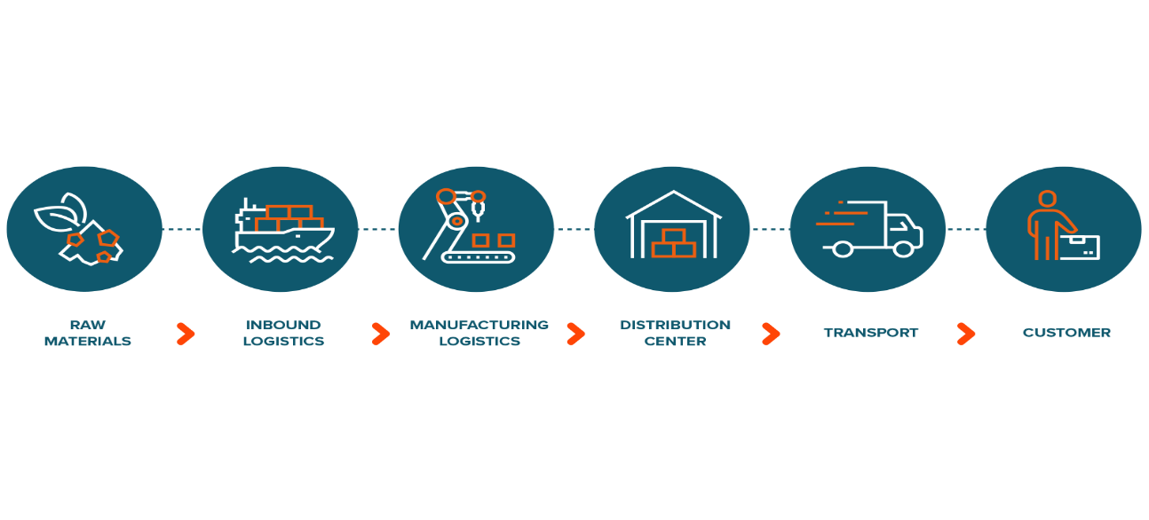

|  |  |  |  |
| --- | --- | --- | --- |
| **Date** | **Time of Arrival** | **Time of Depart** | **Today’s Assignment/Section** |
| 6-06-2023 | 9:00AM | 3:00 PM | Sales & Customer Handle |

Sales refer to the activities and processes involved in selling products or services to customers. It is a fundamental aspect of business that focuses on generating revenue and driving growth. Sales can occur through various channels, such as direct selling, e-commerce platforms, retail stores, or business-to-business interactions.

The sales process typically involves the following steps:

1. Prospecting: Identifying and targeting potential customers or leads who may have an interest in the product or service being offered.
2. Qualification: Assessing the leads to determine their suitability as potential customers, considering factors such as their needs, budget, authority to make purchasing decisions, and timeline.
3. Needs Analysis: Understanding the customer's requirements, pain points, and objectives to tailor the sales approach and highlight the benefits that meet their specific needs.
4. Presentation and Demonstrations: Presenting the product or service to the customer, showcasing its features, functionality, and value proposition. This may involve demonstrations, samples, or visual aids to effectively communicate the benefits.
5. Handling Objections: Addressing any concerns, doubts, or objections raised by the customer and providing relevant information or reassurance to overcome them.
6. Negotiation and Pricing: Negotiating the terms of the sale, including pricing, discounts, payment terms, and any additional services or customization required.
7. Closing the Sale: Obtaining the customer's commitment to make a purchase and finalizing the transaction. This may involve signing contracts, processing payment, and arranging delivery or implementation.
8. Follow-up and After-sales Service: Maintaining contact with the customer after the sale to ensure their satisfaction, address any post-purchase concerns, and foster long-term relationships. This can include providing support, warranty services, or upselling and cross-selling additional products or services.

Sales teams may use customer relationship management (CRM) software to track leads, manage customer interactions, and analyse sales data. This helps them streamline their sales processes, identify trends, and make informed decisions to optimize their sales efforts.

Successful sales execution requires effective communication, active listening, product knowledge, negotiation skills, and a customer-centric approach. Organizations invest in sales training, incentives, and performance measurement to empower their sales teams and drive revenue growth.

A successful salesperson knows how to handle customers effectively to build rapport, understand their needs, and guide them towards a purchase decision. Here are some key tips for salespeople to handle customers:

1. Active Listening: Pay close attention to what the customer is saying and ask clarifying questions to understand their needs and expectations. Listening actively demonstrates empathy and helps you tailor your approach accordingly.
2. Build Rapport: Establish a positive and friendly rapport with the customer. Show genuine interest in their concerns and engage in small talk to create a comfortable and trusting environment.
3. Ask Open-ended Questions: Use open-ended questions to encourage customers to provide detailed responses. This allows you to gather valuable information about their needs, preferences, and pain points, which you can address in your sales pitch.
4. Product Knowledge: Have a deep understanding of your product or service. Be prepared to answer questions, provide demonstrations, and explain how your offering solves the customer's problem or meets their needs.
5. Highlight Benefits: Focus on the benefits and value your product or service provides rather than just listing features. Explain how it can improve the customer's life, solve their challenges, or help them achieve their goals.
6. Handle Objections: Anticipate and address any objections or concerns the customer may have. Listen attentively to their objections, acknowledge their concerns, and provide relevant information or solutions to alleviate their doubts.
7. Tailor Your Approach: Adapt your sales approach to the customer's communication style and preferences. Some customers may prefer a more direct and data-driven approach, while others may respond better to storytelling or emotional appeals.
8. Be Transparent and Honest: Build trust by being transparent and honest with the customer. Avoid making false claims or overpromising. If you don't have an answer to a question, admit it and offer to find the information later.
9. Overcome Price Concerns: If price is a concern, emphasize the value and return on investment (ROI) your product or service offers. Discuss long-term benefits or cost savings that outweigh the upfront cost.
10. Follow-Up: After the sale, follow up with the customer to ensure their satisfaction and address any additional questions or concerns. This demonstrates your commitment to their success and helps foster long-term relationships.
11. Remember, every customer is unique, and it's essential to tailor your approach to their specific needs and preferences. Building trust, providing exceptional customer service, and delivering value is key to successful customer handling in sales.

Remember, every customer is unique, and it's essential to tailor your approach to their specific needs and preferences. Building trust, providing exceptional customer service, and delivering value is key to successful customer handling in sales.

|  |  |  |  |
| --- | --- | --- | --- |
| **Date** | **Time of Arrival** | **Time of Depart** | **Today’s Assignment/Section** |
| 7-06-2023 | 9:00AM | 3:00 PM | Accounting |

Accounting is incredibly important for any company because it provides crucial financial information that is essential for decision-making, financial management, and compliance. It allows businesses to track their income, expenses, and cash flow, providing a clear picture of their financial health. Accurate accounting enables companies to plan budgets, allocate resources effectively, and make informed strategic decisions. Moreover, accounting ensures compliance with legal and regulatory requirements, providing transparency and building trust with stakeholders. It also facilitates financial reporting, allowing companies to communicate their financial performance to investors, creditors, and other interested parties. In summary, accounting is vital for the financial stability, growth, and success of any company.

1. Financial Management: Accounting provides essential financial information that helps businesses effectively manage their resources and make informed decisions. It enables companies to track income, expenses, and cash flow, facilitating better financial planning, budgeting, and resource allocation.
2. Tax Compliance: Accurate accounting ensures compliance with tax laws and regulations. Companies are required to maintain proper records, calculate taxes accurately, and submit timely tax returns. Failure to comply with tax obligations can lead to penalties or legal issues.
3. Financial Reporting: Accounting generates financial statements that summarize a company's financial performance, position, and cash flows. These reports, including income statements, balance sheets, and cash flow statements, are vital for stakeholders, such as investors, lenders, and shareholders, to assess the company's financial health and make informed decisions.
4. Stakeholder Communication: Accounting facilitates communication with various stakeholders, such as investors, creditors, suppliers, and customers. Accurate financial information helps build trust and transparency, allowing stakeholders to evaluate the company's financial stability, growth prospects, and creditworthiness.
5. Business Valuation: Proper accounting practices contribute to an accurate assessment of a company's value. Investors, potential buyers, or partners may use financial statements to evaluate the company's worth and make investment or acquisition decisions.
6. Legal Compliance and Governance: Accounting helps ensure compliance with legal and regulatory requirements, including financial reporting standards, corporate governance guidelines, and industry-specific regulations. Proper accounting practices enhance transparency, mitigate risks, and foster good corporate governance.
7. Internal Controls: Accounting systems and processes establish internal controls that safeguard company assets, prevent fraud, and detect errors. These controls include segregation of duties, regular financial reconciliations, and internal audits.
8. Financial Planning and Forecasting: Accounting data provides a foundation for financial planning and forecasting. Companies can analyse historical financial information to make informed projections, set realistic goals, and assess the feasibility of new projects or ventures.
9. Decision Making and Strategy: Accounting information helps management evaluate the financial impact of various decisions, strategies, and investments. It assists in assessing profitability, cost-effectiveness, and return on investment, enabling data-driven decision-making.

|  |  |  |  |  |  |
| --- | --- | --- | --- | --- | --- |
| **Punctuality** | **Initiatives** | **Innovativeness** | **Sense Of Responsibility** | **Sense Of Discipline** | **Drive For**  **Completion Of Task** |
|  |  |  |  |  |  |
|  |  |  |  |  |  |

(The boxes are to be filled in by any suitable term from ‘very good’, ‘good’, and ‘average’, ‘poor’.)

Supervisor’s signature Designation: Assistant Manager

Date: 07-06-2023

## Bangladesh Army University of Engineering & Technology (BAUET) Department of Computer Science & Engineering (CSE)

#### Course: CSE-3224, Industrial Training GUIDELINES FOR THE INDUSTRIAL SUPERVISOR

1. During the period of their industrial training, the student (henceforth internee) will perform the duties assigned by the organization, and a program agreed upon with the organization adds the department. During this period, the internee works under the supervision and guidance of an industrial supervisor as well as and academic supervisor. The industrial supervisor will be appointed by the interning organization. Keeping in view the objective and structure of internship, the supervisor will prepare a program for the internees to familiarize them with the practical aspects of engineering and management in general and that of the host organization in particular.
2. The internee is required to attend the office regularly and punctually. He/ She must seek prior permission from the industrial supervisor to remain absent by submitting a leave application, a copy of which should also be sent by the internee to the Head, CSE. The industrial supervisor if the internees will deal with attendance and leave of the internees, take appropriate measures and keep record thereof.
3. In the three weeks, the students will have and orientation of the organization and its function by being route through its various divisions, department and section. During this period, they will write their daily log of activities and get it signed from the industrial supervisor. The student will be preparing a report in a prescribed format or a format suggested by the industrial supervisor and academic supervisor. The industrial supervisor will examine the report and give his confidential comments on the report.
4. The internee is also required to undertake a study work on technical or managerial problem of the organization. The work calls for selection of problems, collection and analysis of data and recommendation of solutions. The student in conclusions with the supervisor in the organization and the academic supervisor will select the problem. After Approval he/ she is to collect and analyze data during the period of internship in the organization and finalizes the report. A copy of the report will be forwarded to organization by CSE Department after evaluation and grading. The field supervisor should guide the internee in identifying and selecting the problem and provide administrative support and extend facilities for data collection.
5. The internee has been given organization on the tasks involved in internship program and desired behavior pattern during his/her stay in the organization. They have been instructed to abide by the rules and regulations of the organization and follow the instruction of the supervisor. The supervisor can help the internee by extending organization co-operations, advice and making him /her accountable for routine duties assigned by the organization.

**REPORT ON INDUSTRIAL TRAINING**



# Bangladesh Army University of Engineering & Technology (BAUET)

## Department of Computer Science and Engineering (CSE)

Name of the student : Md. Arik Rayhan

Student ID : 20104033

Name of the organization : BRACNet

Address of the organization : 16 Mohakhali C/A, Dhaka-1212

#### Signature of the student

**Personal Statement**

Photograph

Name of the student : Md. Arik Rayhan

|  |  |  |  |  |  |  |  |
| --- | --- | --- | --- | --- | --- | --- | --- |
| 2 | 0 | 1 | 0 | 4 | 0 | 3 | 3 |

Student ID :

Date of reporting : 15-05-2023

Date of departure : 07-06-2023

Accommodation during training : Super Home -7, Badda Branch

Arrangement for food during training: Rice, Chicken, Fish, Mutton, etc.

Description of illness during training (if any): None

#### The above statement is to be attested by the training In-Charge

Name of the training-in-charge (with position):

Afrin Kawsar, Assistant Manager, Human Resources, BRACNet.

Signature (office seal)

Date: 07-06-2023